D.K.T.E. Society’s Textile and Engineering Institute, Ichalkaranji.
(An Empowered Autonomous Institute, Affiliated to Shivaji University, Kolhapur)
Department of Computer Science & Engineering (Artificial Intelligence and Machine Learning)
2025-26

A Project Synopsis
On
VIRTUAL_COACH

SUBMITTED BY

MISS. AFREEN WAJEED KADEGAONKAR 23UAM039
MR. AAYAN TAJUDDIN MUJAWAR 23UAM079
MR. MOHMMADNUH NASRUDDIN MUJAWAR 23UAM080
MR. ADITYA SANDEEP SAVALE 23UAM123
MR. GOUTAM TARAPRAKASH VAISHNAV 23UAM136

UNDER THE GUIDANCE OF

V.B.SUTAR

Prof. Dr.L.S. Admuthe Prof. Dr. S. K.Shirgave
[Project Guide] [I/C Director] HOD (CSE(AI & ML))

D.K.T.E. Society’s Textile and Engineering Institute,
Ichalkaranji.

(An Autonomous Institute, Affiliated to Shivaji University, Kolhapur)

Department of Computer Science & Engineering (Artificial Intelligence and Machine Learning)

CERTIFICATE
This is to certify that,

1. 23UAM039 AFREEN WAJEED KADEGAONKAR
2. 23UAM079 AAYAN TAJUDDIN MUJAWAR
3. 23UAM080 MOHMMADNUH NASRUDDIN MUJAWAR
4. 23UAM123 ADITYA SANDEEP SAVALE
5. 23UAM136 GOUTAM TARAPRAKASH VAISHNAV

Have successfully completed the Synopsis of the mega project Entitled,
PoseSense AI – AI-Based Human Posture Analysis & Performance Evaluation System
In partial fulfillment for Final Year B.Tech. CSE(AI) academics. This is the record of their work carried out during the Academic year 2025-2026.

Date: Place: Ichalkaranji

Prof. Prof. Dr.L.S. Admuthe Prof. Dr. S. K. Shirgave
(Project Guide) (I/C Director) (HOD CSE-AIML)

D.K.T.E Society’s Textile and Engineering Institute, Ichalkaranji

VIRTUAL_COACH
Synopsis of Proposed Work Submitted to

Department of CSE(AIML) Engineering

For the Degree of
Bachelor of Technology
In

CSE(Artificial Intelligence and Machine Learning) by

23UAM079 Aayan T Mujawar
23UAM080 Mohmmadnuh N Mujawar
23UAM123 Aditya S Savale
23UAM136 Goutam T Vaishnav
23UAM039 Afreen W Kadegaonkar

Under the Guidance of
Prof. V.B.Sutar
Academic Year

2025– 2026

▪ INTRODUCTION

This project falls under the domain of Artificial Intelligence and Computer Vision, focusing on human pose estimation and motion analysis for sports applications. It integrates Machine Learning and Deep Learning techniques to analyze athlete performance using video data. In sports like Cricket, proper posture and technique are essential, but traditional training methods rely heavily on manual observation by coaches, which can be subjective and inconsistent. Many aspiring athletes, especially in rural areas, lack access to professional coaching and advanced performance analysis tools. Additionally, existing motion analysis systems are often expensive and not easily accessible, creating a need for an affordable and intelligent solution that can automatically evaluate posture and provide accurate feedback.

To address these challenges, the proposed system applies computer vision techniques to analyze cricket batting and bowling posture using video-based pose estimation. The system detects body joints, compares them with ideal techniques, and provides real-time feedback, posture correction suggestions, and injury risk alerts. It aims to develop a mobile-based application that ensures accessibility and ease of use for a wide range of users. This solution can be effectively used in sports academies, training centers, and for self-practice by athletes, helping improve performance, prevent injuries, and support talent development through an affordable and scalable approach.

▪ RELATED WORK

➢ Paper 1: “Real-Time Human Pose Estimation Using MediaPipe for Fitness Applications”

- Summary of Work:
This paper presents a system that uses MediaPipe pose estimation to detect human body keypoints in real time from video input. The system tracks joints such as shoulders, elbows, hips, and knees, and applies this information for basic fitness monitoring. It demonstrates how pose estimation can be used for analyzing simple exercises and movements.

- Limitations:

- Does not provide detailed posture correction feedback
- Limited to basic fitness activities, not sports-specific techniques
- No performance scoring or ranking system
- Not integrated into a complete mobile application system

➢ Paper 2: “Deep Learning-Based Human Activity Recognition Using Video Analysis”

- Summary of Work:

This paper focuses on using deep learning models (CNN/LSTM) to recognize human activities from video sequences. It analyzes motion patterns over time and classifies actions such as running, walking, and jumping. The system improves accuracy by learning temporal patterns from sequential data.

- Limitations:

• Focuses only on activity recognition, not posture quality

• Requires large labeled datasets for training

• Does not provide real-time feedback or correction

• Not specifically designed for sports performance analysis

➢ Paper 3 (“AI-Based Sports Performance Analysis Using Pose Estimation Techniques”)

• How limitations of Paper 2 are overcome:-

• Paper 2 only performs activity recognition (e.g., running, jumping), while Paper 3 analyzes posture quality and movement correctness.
• Paper 2 does not evaluate body joint angles, whereas Paper 3 uses pose estimation to measure joint positions and angles.
• Paper 2 lacks sports-specific analysis, while Paper 3 focuses on sports performance evaluation.
• Paper 2 does not provide feedback for improvement, whereas Paper 3 identifies incorrect posture and gives meaningful insights.
• Paper 3 provides a more practical approach for real-world applications like athlete training compared to Paper 2.
• Summary of Work:

This paper proposes a system that uses pose estimation to analyze sports movements and compare them with ideal techniques. It evaluates body joint angles and movement patterns to assess performance quality. The approach helps in identifying incorrect posture in athletes.
• Scope for Modification and Implementation:

• The existing system can be enhanced by integrating it into a mobile application for easy accessibility.
• Real-time video processing can be implemented to provide instant posture feedback instead of offline analysis.
• The system can be extended to include injury risk detection based on incorrect posture patterns.
• Additional features like performance scoring and athlete ranking can be incorporated.

▪ PROBLEM DESCRIPTION

In sports such as cricket, maintaining correct posture and technique is crucial for achieving optimal performance and preventing injuries. However, many aspiring players, especially in rural or resource-limited areas, do not have access to professional coaching or advanced training facilities. As a result, they often practice without proper guidance, which can lead to the development of incorrect techniques and increased risk of injuries.
Traditional methods of performance analysis rely heavily on manual observation by coaches, which can be subjective, time-consuming, and inconsistent. Moreover, continuous monitoring of every player is not always feasible. Existing technological solutions for motion analysis are often expensive and require specialized equipment, making them inaccessible to a large number of athletes.
Therefore, there is a need for an affordable and intelligent system that can automatically analyze a player's posture using video input. Such a system should provide accurate feedback, suggest improvements, and help in injury prevention, making professional-level guidance accessible to all players.

▪ PROBLEM STATEMENT

To design and develop an AI-powered system that analyzes cricket player posture using video input and computer vision techniques, in order to evaluate performance, detect incorrect movements, and provide feedback for improvement and injury prevention in an accessible and cost-effective manner.

▪ OBJECTIVES

• To design and implement a system that analyzes cricket posture from video input using computer vision and machine learning techniques for performance evaluation. (Functional Objective)

• To develop a posture analysis module that detects body joints, identifies incorrect movements, and provides feedback along with corrective suggestions and injury prevention guidance. (Functional Objective)

• To evaluate and optimize the system’s performance in terms of accuracy, response time, and reliability for real-time or near real-time analysis. (Performance Objective)

• To ensure the system is user-friendly, scalable, and adaptable across different users, environments, and video conditions using a mobile-based platform. (Non-Functional Objective)

METHODOLOGY :

- MODULE ARCHITECTURE DIAGRAM:-

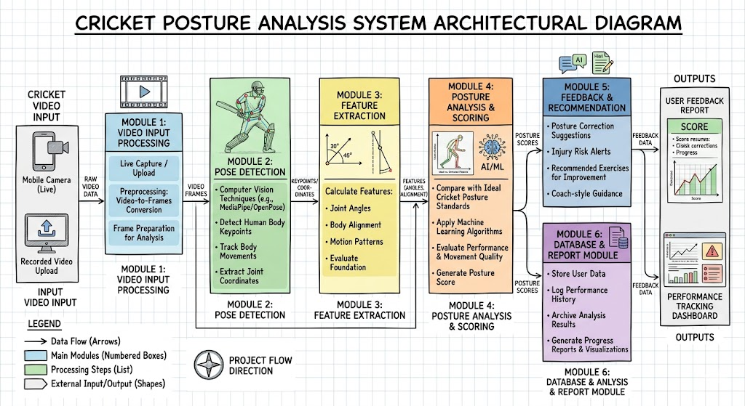

- MODULE DESCRIPTION:-

The proposed system follows a multi-stage pipeline architecture consisting of speech recognition, semantic repair using multi-agent collaboration, and fluent speech synthesis. The architectural diagram illustrates how stuttered speech is processed step-by-step to produce semantically accurate and fluent audio output. The design emphasizes modularity, semantic preservation, and real-time performance.

- MODULES:-

- 1. Video Input Module
This module is responsible for capturing live video through the mobile camera or allowing users to upload recorded cricket videos. It preprocesses the video by converting it into frames and preparing it for further analysis.

- 2. Pose Detection Module
This module uses computer vision techniques to detect human body keypoints such as shoulders, elbows, hips, and knees from video frames. It tracks body movements and extracts joint coordinates required for posture analysis.

- 3. Feature Extraction Module
In this module, important features such as joint angles, body alignment, and motion patterns are calculated from the detected keypoints. These features form the basis for evaluating posture and performance.

- 4. Posture Analysis and Scoring Module
This module compares the extracted features with predefined ideal cricket posture standards. It uses machine learning algorithms to evaluate performance and generate a score based on accuracy and movement quality.

- 5. Feedback and Recommendation Module
Based on the analysis, this module provides feedback to the user, including posture correction suggestions, injury risk alerts, and recommended exercises to improve performance.

- 6. Database and Report Module
This module stores user data, performance history, and analysis results. It also generates reports and visualizations that help users track their progress over time.

▪ FACILITIES REQUIRED :

➢ Hardware Requirements:

- Personal Computer / Laptop with minimum Intel i5 or equivalent processor
- At least 8 GB RAM (16 GB recommended for better performance)
- Android smartphone with camera for video capture
- Stable internet connection

2. Software Requirements:

- Operating System: Windows / Linux / macOS
- Programming Language: Python
- Android Development: Android Studio
- Libraries/Frameworks: OpenCV, MediaPipe, TensorFlow / PyTorch
- Database: Firebase or MySQL

3. Dataset Requirements:

- Cricket action videos (batting/bowling)
- Publicly available sports motion datasets
- Self-recorded videos for training and testing
- Labeled data including posture correctness and action type

4. Other Requirements:

- Basic knowledge of Machine Learning and Computer Vision
- Tools for data preprocessing and annotation
- Testing environment for evaluating model performance

▪ REFERENCES :

[1] Z. Cao, T. Simon, S. E. Wei, and Y. Sheikh,
“Realtime Multi-Person 2D Pose Estimation using Part Affinity Fields,”
CVPR, 2017.
🔗 https://arxiv.org/abs/1611.08050

[2] J. Shotton et al.,
“Real-Time Human Pose Recognition in Parts from Single Depth Images,”
CVPR, 2011.
🔗 https://ieeexplore.ieee.org/document/5995316

[3] T. Pfister, J. Charles, and A. Zisserman,
“Flowing ConvNets for Human Pose Estimation in Videos,”
ICCV, 2015.
🔗 https://arxiv.org/abs/1507.02839

[4] K. Simonyan and A. Zisserman,
“Two-Stream Convolutional Networks for Action Recognition in Videos,”
NIPS, 2014.
🔗 https://arxiv.org/abs/1406.2199

[5] G. Varol, I. Laptev, and C. Schmid,
“Long-Term Temporal Convolutions for Action Recognition,”
TPAMI, 2018.
🔗 https://arxiv.org/abs/1703.01921

[6] Google Research,
“MediaPipe: A Framework for Building Perception Pipelines,”
🔗 https://mediapipe.dev/

[7] A. Toshev and C. Szegedy,
“DeepPose: Human Pose Estimation via Deep Neural Networks,”
CVPR, 2014.
🔗 https://arxiv.org/abs/1312.4659

[8] S. Wei et al.,
“Convolutional Pose Machines,”
CVPR, 2016.
🔗 https://arxiv.org/abs/1602.00134

[9] Z. Fang et al.,
“RMPE: Regional Multi-person Pose Estimation,”
ICCV, 2017.
🔗 https://arxiv.org/abs/1612.00137

[10] D. Tran et al.,
“Learning Spatiotemporal Features with 3D Convolutional Networks,”
ICCV, 2015.
🔗 https://arxiv.org/abs/1412.0767

[11] J. Carreira and A. Zisserman,
“Quo Vadis, Action Recognition? A New Model and the Kinetics Dataset,”
CVPR, 2017.
🔗 https://arxiv.org/abs/1705.07750

[12] H. K. K. et al.,
“Human Activity Recognition Using Machine Learning Techniques,”
IEEE Access, 2019.
🔗 https://ieeexplore.ieee.org/document/8758605

[13] M. Andriluka et al.,
“2D Human Pose Estimation: New Benchmark and State of the Art Analysis,”
CVPR, 2014.
🔗 https://arxiv.org/abs/1406.2984

[14] B. Xiao, H. Wu, and Y. Wei,
“Simple Baselines for Human Pose Estimation and Tracking,”
ECCV, 2018.
🔗 https://arxiv.org/abs/1804.06208

[15] N. Neverova et al.,
“ModDrop: Adaptive Multi-Modal Gesture Recognition,”
TPAMI, 2016.
🔗 https://arxiv.org/abs/1511.06803

